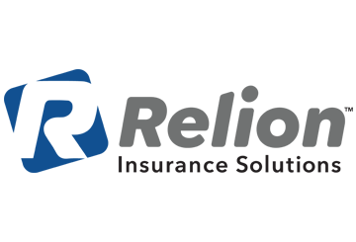
CDC Recommends Wearing a Mask When You Go Out in Public
Provided by: Relion Insurance Solutions
During the White House Coronavirus Task Force briefing on Friday, April 3, President Donald Trump announced new guidance for the American public to protect themselves against coronavirus disease 2019 (COVID-19). This new guidance from the Centers for Disease Control and Prevention (CDC) states that Americans should wear nonmedical-grade, cloth masks when they go out in public.

Why was this guidance issued?
COVID-19 cases continue to increase throughout the United States, despite social distancing efforts. Because individuals can have the disease without exhibiting symptoms, they can unknowingly spread it when they go out in public to gather groceries or other essential supplies.
This announcement is a new development in the administration’s stance on wearing face masks. However, the Department of Health and Human Services Secretary Alex Azar said in a statement, “While we don’t have evidence that a cloth mask protects you from acquiring the virus, the science suggests it will help prevent you from spreading it to others—a key way to protect the most vulnerable, slow the spread and save lives.”

What types of masks should be worn?
The CDC stresses that individuals should opt for cloth masks that can be washed or nonmedical-grade disposable masks that cover their mouth and nose. Individuals should not purchase N95 or surgical masks, as those masks should be reserved for health care professionals.
The CDC has issued a step-by-step guide on how to make a cloth mask at home, and how to properly wear one in public. Please follow the guidance provided on the CDC website for best practices to stay safe while wearing a face mask.

“[The] CDC recommends wearing cloth face coverings in public settings where other social distancing measures are difficult to maintain (e.g., grocery stores and pharmacies) especially in areas of significant community-based transmission.”
- CDC website

What does this mean for you?
The COVID-19 pandemic continues to spread throughout the country. To prevent the spread of COVID-19, consider wearing a face mask as instructed by the CDC when you go out in public.
For more information on the COVID-19 pandemic, contact Relion Insurance Solutions today.

