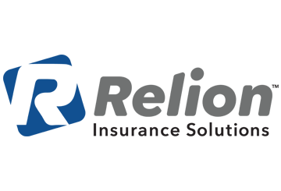
Easing Employee Stress Surrounding the Coronavirus Pandemic
Brought to you by the insurance professionals at
Relion Insurance Solutions
The coronavirus disease 2019 (COVID-19) pandemic, which was first detected in Wuhan, China in late December 2019, has now spread to over 150 countries, including the United States. As the number of confirmed cases increases daily, employers, employees and their families are experiencing immense uncertainty.
As businesses across the country are temporarily closing, many aren’t able to compensate their employees during the closures. While this may not be the case for your organization, many of your employees may be experiencing anxiety and stress due to the pandemic.
In uncertain times such as these, employees are looking for guidance wherever they can find it. Employers can help calm some of their employees’ fears by taking the following actions:
- Acknowledge employee fears surrounding their jobs and the company, but also reassure them of their value to the company and the company’s desire to keep them as members of the team.
- Be open with employees about management decisions and ask for suggestions to rectify problems.
- Provide as much information as possible about the pandemic.
- Highlight employee benefits that employees might not know about to relieve any financial stress.
- Encourage employees to take advantage of any telemental health services to preserve their mental well-being.
- Communicate the future of the business with employees often—in meetings, on the company intranet site, in newsletters and in blogs.
- Be empathetic in your communications, as every employee’s situation may be different.
The COVID-19 pandemic is understandably causing uncertainty for employees and their families. Many are trading their normal day-to-day routine for alternative working arrangements. Some employees are also faced with the task of balancing telecommuting and caregiving responsibilities. On top of that, the pandemic situation is fluid, meaning new information is being released daily.
In these uncertain times, it’s imperative that you clearly communicate your business’s plans as frequently as possible. It’s not possible for you to control the pandemic, but it is possible for you to help ease the stress your employees are experiencing.
For additional employee communications or resources regarding the COVID-19 pandemic, contact Relion Insurance Solutions today.

