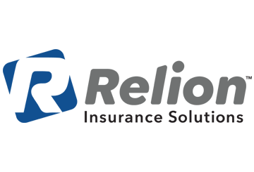

WHAT TO DO IF YOU’RE SICK WITH COVID-19

According to the Centers for Disease Control and Prevention, coronavirus disease 2019 (COVID-19) is caused by a type of coronavirus that can spread from person to person and cause respiratory illness.

The majority of patients with COVID-19 experience mild to moderate respiratory illness with the following symptoms:

* Fever
* Cough
* Shortness of breath

Some patients, including the elderly and those with compromised immune systems or underlying health conditions are considered to be at a higher risk of developing severe illness.

Action Steps if You’re Sick

If you suspect that you’re sick with COVID-19, follow the steps below to help prevent the disease from spreading to people in your home and community.

* Stay home—Do not go outside your home, except for getting medical care. Make sure to call ahead prior to seeking care.
* Avoid public areas—Do not go to work, school or public areas outside of medical facilities.
* Avoid public transportation—Avoid using public transportation, ride-sharing or taxis.
* Self-isolate—If you have COVID-19, you should self-isolate for as long as your doctor recommends.
* Follow treatment guidelines—The vast majority of cases of COVID-19 are mild and can be treated at home by getting enough fluids and rest, and taking any prescribed medication.
* Monitor your symptoms—If your symptoms worsen or you experience any shortness of breath, call your doctor immediately. They may recommend that you seek further treatment.
* Practice good hygiene—If you’re sick, you need to practice good hygiene, which includes:
  + Covering your mouth or nose with a tissue when you cough or sneeze
  + Disposing of used tissues in a trash can
  + Washing your hands with soap and warm water for at least 20 seconds after you cough or sneeze and frequently throughout the day

Health and wellness tips for your work, home and life—brought to you by the insurance professionals at Relion Insurance Solutions

Action Steps if a Loved One Is Sick

COVID-19 can spread through close human-to-human contact. As such, if a loved one in your home is sick with COVID-19, public health officials are asking that you self-quarantine as well, unless you need medical treatment. In addition, you should:

* Frequently wash your hands with soap and warm water for at least 20 seconds.
* Avoid touching your eyes, nose and mouth with unwashed hands.
* Try to keep 6 feet of distance between you and an ill loved one.
* Do not share dishes, drinking glasses, cups, utensils, towels or bedding with others in your home. Be sure to wash these items with soap and water after each use.
* Clean and disinfect high-touch surfaces like countertops, tabletops, doorknobs, faucets, toilets, phones, tablets and remotes frequently.

Summary

The COVID-19 pandemic is something that you should take very seriously. By following the guidance provided by public health officials, you can do your part to minimize further spread of the disease while still obtaining necessary medical care.